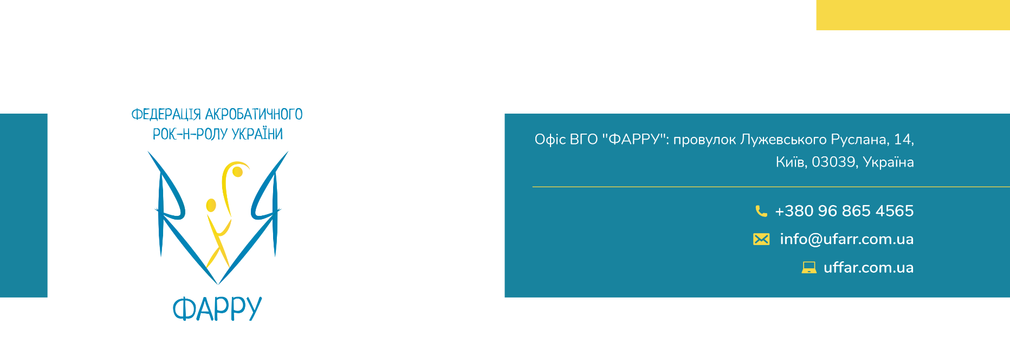

FOR WORLD CHAMPIONSHIP ACROBATIC ROCK’N’ROLL
JUNIORS/ MAIN CLASS CONTACT STYLE/ FORMATION GIRLS
WORLD CHAMPIONSHIP BOOGIE WOOGIE
JUNIORS/ MAIN CLASS/SENIORS
EUROPEAN CHAMPIONSHIP ACROBATIC ROCK’N’ROLL
FORMATION JUNIORS
WORLD CUP ACROBATIC ROCK’N’ROLL
CHILDREN/ JUVENILES
23-24.10.2021
KHARKIV – UKRAINE

RESERVATION ORDER FORM

HOTEL, TRANSPORT, MEAL, TICKETS

COUNTRY:

NAME/CLUB:

PHONE NUMBER:

E-MAIL:

HOTEL RESERVATION
*Please pay attention that prices are indicated in national currency (Ukrainian hryvnia), approximate prices in Euros are shown nearby.

HOTEL and Room type: | Number of rooms | Check in  Date | Check out  Date | Number  of nights | To pay in € | To pay in UAH
 |  | 22.10.2021 12:00 | 25.10.2021 12:00
 |  | 22.10.2021 12:00 | 25.10.2021 12:00
 |  | 22.10.2021 12:00 | 25.10.2021 12:00
 |  | 22.10.2021 12:00 | 25.10.2021 12:00
 |  | 22.10.2021 12:00 | 25.10.2021 12:00
 |  | 22.10.2021 12:00 | 25.10.2021 12:00
 |  | 22.10.2021 12:00 | 25.10.2021 12:00
 |  | 22.10.2021 12:00 | 25.10.2021 12:00
4 € ( per night city/tourist tax) - adults - persons
1 € (per night city/tourist tax) – children 6-18 - persons
TOTAL in UAH:

LUNCH
 | Number of lunches | To pay in € | To pay in UAH
180 UAH / 7 € / 1 lunch 23.10
180 UAH / 7 € / 1 lunch 24.10

TICKETS RESERVATION
 | Number of tickets | To pay in € | To pay in UAH
350 UAH/ 12 € - 1 day ticket
500 UAH/ 17 € - 2 days ticket

TRANSPORT RESERVATION: KHARKIV
Kharkiv Airport – Hotel – Sport hall – Hotel – Kharkiv Airport
 | Number of persons | To pay in € | To pay in UAH
450 UAH / (15 €)/ per person

Arrival-Information: Airport: Kharkiv
Airline
Flight-Number
Date and Time of Arrival | 22.10.2021 0:00

Departure-Information: Airport: Kharkiv
Airline
Flight-Number
Date and Time of Departure | 25.10.2021 0:00

TRANSPORT RESERVATION: BELGOROD
Airport / Railway Station – Hotel – Sport hall – Hotel – Airport / Railway Station
 | Number of persons | To pay in € | To pay in UAH
1500 UAH / (45 €) / per person

Arrival-Information: Airport/ Railway Station: Belgorod
Airline / Train
Flight-Number / Wagon
Date and Time of Arrival | 22.10.2021 0:00

Departure-Information: Airport/ Railway Station: Belgorod
Airline / Train
Flight-Number / Wagon
Date and Time of Departure | 25.10.2021 0:00

*Comments:

In case you need some other information please do not hesitate to contact me.
Petrenko Mykhailo
Tel. +380665936248
E-mail: ukraine.worldcup@gmail.com

